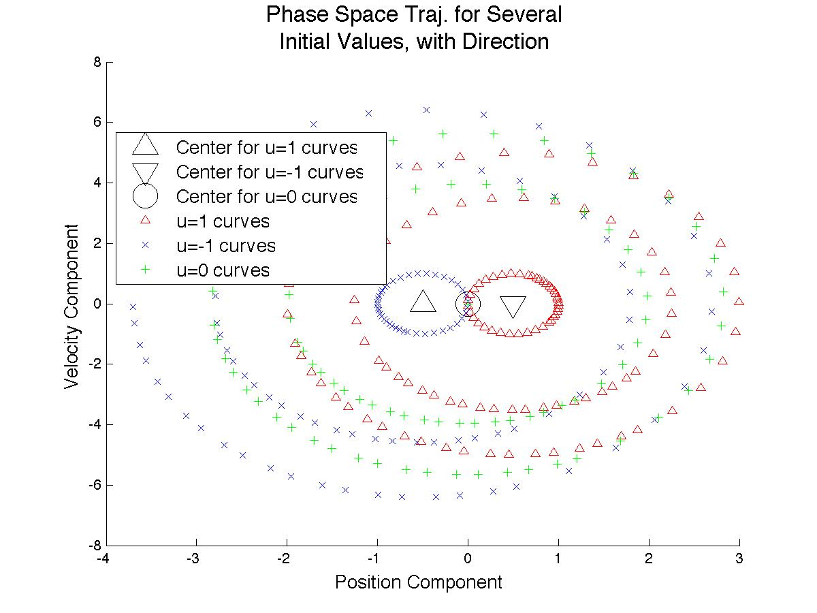

function F = myfun(x,u,w,start,T,NumSwitch, OptCond)

xf = inline('(k/w)\*sin(w\*t) + (j - u/w^2)\*cos(w\*t) + u/w^2', 't', 'u', 'j', 'k','w');

vf = inline('k\*cos(w\*t) - w\*(j - u/w^2)\*sin(w\*t)', 't', 'u','j','k','w');

x1f = inline('k\*sin(w\*t) + j\*cos(w\*t) + u/w^2', 't', 'u', 'j', 'k','w');

v1f= inline('w\*k\*cos(w\*t) - w\*j\*sin(w\*t)', 't', 'u','j','k','w');

% Variable Switching, Bang-off-Bang

% x0 = [SwiTimes; DiffNowToOpt; Coeffs];

Lookup = [0,1,0; 1,0,-1; 0, -1, 0];

times = x(1:NumSwitch);

del = x(NumSwitch+1:2\*NumSwitch-1);

coeffs = x(2\*NumSwitch:end);

F = [xf(times(1),u,start(1),start(2),w) - x1f(times(1),0,coeffs(1),coeffs(2),w);...

vf(times(1),u,start(1),start(2),w) - v1f(times(1),0,coeffs(1),coeffs(2),w);...

coeffs(end)/w\*cos(w\*times(1)) - Lookup(u+2,2)];

for SwiInd = 2:NumSwitch

%Index for new curve coeffs

Start = 2\*(ceil((SwiInd)/2))-1;

End = 2\*(ceil((SwiInd-1)/2));

%Index for opt curve coeffs

Start1 = 2\*(ceil((SwiInd+1)/2))-1+2;

End1 = 2\*(ceil((SwiInd+1)/2))+2;

%Compute u's for opt curves [1 1 -1 -1 1 1...]

u1 = (-u)\*(-1)^((mod(SwiInd-2,4)-mod(SwiInd,2))/2);

F = [F;...

x1f(times(SwiInd)-del(SwiInd-1),u1,OptCond(Start1),OptCond(End1),w) - ...

x1f(times(SwiInd),0,coeffs(Start),coeffs(End),w);...

v1f(times(SwiInd)-del(SwiInd-1),u1,OptCond(Start1),OptCond(End1),w) - ...

v1f(times(SwiInd),0,coeffs(Start),coeffs(End),w)];

if SwiInd<=3

F = [F;coeffs(end)/w\*cos(w\*times(SwiInd)) - Lookup(u1+2,2)];

end

end

F = [F;...

x1f(T-del(end),u1,OptCond(Start1),OptCond(End1),w);...

v1f(T-del(end),u1,OptCond(Start1),OptCond(End1),w);...

T - sum(del) - OptCond(2)];